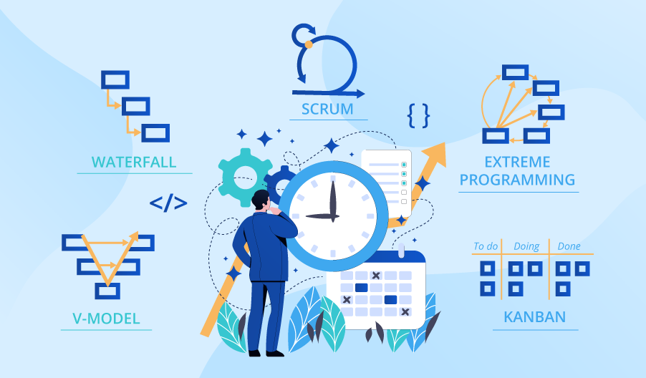

**SE423**

**Software Project Management**

**Assignment**

**Assignment 6.**

Answer the following questions:

1. What are the factors that influence the decision on whether or not a change should be implemented?
2. Explain how advances in technology can force a software subsystem to undergo change or run the risk of becoming useless.
3. As a software project manager in a company that specializes in the development of software for the offshore oil industry, you have been given the task of discovering the factors that affect the maintainability of the systems developed by your company. Suggest how you might set up a program to analyze the maintenance process and determine appropriate maintainability metrics for the company.
4. Briefly describe the three main types of software maintenance. Why is it sometimes difficult to distinguish between them?

Submit your answers to LMS as PDF file.